Lab 3

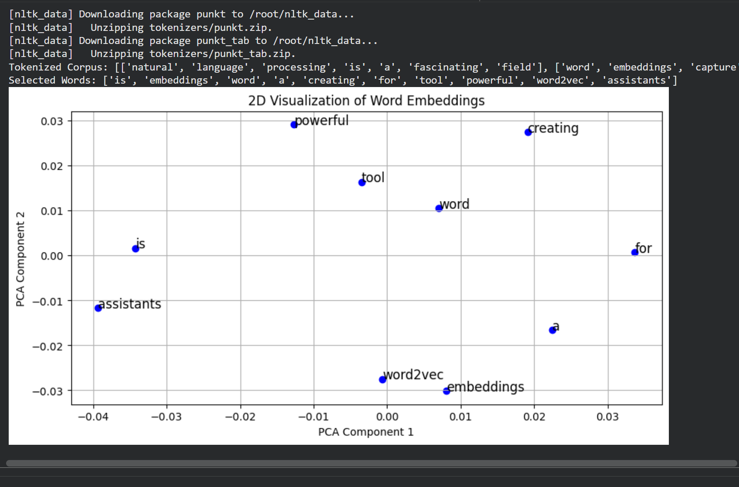

Code
import nltk
from gensim.models import Word2Vec
from nltk.tokenize import word_tokenize
from sklearn.decomposition import PCA
import matplotlib.pyplot as plt

# --- 1. Data Preparation ---

# Download necessary NLTK data
nltk.download('punkt')
nltk.download('punkt_tab')

# Sample corpus of text
corpus = [
"Natural language processing is a fascinating field",
"Word embeddings capture semantic meanings",
"NLP is used in chatbots and virtual assistants",
"Word2Vec is a powerful tool for creating word embeddings"
]

# Tokenize sentences (convert sentences into lists of lowercase words)
tokenized_corpus = [word_tokenize(sentence.lower()) for sentence in corpus]
print("Tokenized Corpus:", tokenized_corpus)

# --- 2. Model Training ---

# Train Word2Vec model
# vector_size=100: Dimensionality of the word vectors
# window=5: Maximum distance between the current and predicted word within a sentence
# min_count=1: Ignores all words with total frequency lower than this
model = Word2Vec(sentences=tokenized_corpus, vector_size=100, window=5, min_count=1, workers=4)

# Save and load the model (optional demonstration of persistence)
model.save("word2vec.model")
model = Word2Vec.load("word2vec.model")

# --- 3. Extract Vectors ---

# Get the list of all unique words in the vocabulary
# We select the first 10 words for visualization to keep the plot clean
words = list(model.wv.index_to_key)[:10]
print("Selected Words:", words)

# Retrieve the vector representation for each selected word
word_vectors = [model.wv[word] for word in words]

# --- 4. Visualization (PCA) ---

# Apply PCA to reduce vectors from 100 dimensions to 2 dimensions for plotting
pca = PCA(n_components=2)
pca_result = pca.fit_transform(word_vectors)

# Create the plot
plt.figure(figsize=(10, 5))
plt.scatter(pca_result[:, 0], pca_result[:, 1], color='blue')

# Annotate the points with the actual words
for i, word in enumerate(words):
plt.annotate(word, xy=(pca_result[i, 0], pca_result[i, 1]), fontsize=12)

# Add titles and labels
plt.title("2D Visualization of Word Embeddings")
plt.xlabel("PCA Component 1")
plt.ylabel("PCA Component 2")
plt.grid(True)
plt.show()

